Conceptual Architecture of an IVI System Integrating Media, Navigation and Projection Features
Project Report — Module 6

1. Abstract
In-Vehicle Infotainment (IVI) systems provide drivers and passengers with digital services such as media playback, navigation and information projection. A modern IVI system integrates multiple software and hardware components to provide these functions through a unified interface.
This project presents a conceptual architecture of an IVI system integrating media, navigation and projection features. The architecture describes the major components, their interfaces and the flow of information between different parts of the system.
The proposed system receives user inputs through the vehicle's infotainment interface and processes them through appropriate application and service layers. Media services manage audio and media content, navigation services process location and route information, and projection features deliver selected information to appropriate vehicle displays.

2. Introduction
In-Vehicle Infotainment systems have become an important part of modern vehicles. They combine entertainment, navigation and information services within the vehicle environment.
An IVI system allows users to interact with applications and services through an infotainment display. Media functionality can provide music and other audio content, while navigation functionality provides route guidance and location information. Projection functionality can present relevant information to a suitable display.
A well-designed IVI architecture separates different functions into appropriate components while allowing them to communicate through defined interfaces.

3. Problem Statement
A vehicle infotainment system needs to integrate multiple functions while maintaining organized communication between applications, services and vehicle interfaces.
The objective of this project is to design a conceptual IVI architecture that integrates:
- Media
- Navigation
- Projection
The architecture should also identify the interfaces and data flow between these components.

4. Objectives
- To design a conceptual architecture for an IVI system.
- To integrate media functionality.
- To integrate navigation functionality.
- To integrate projection functionality.
- To identify major system components.
- To define communication and data flow between components.
- To provide a structured model of an automotive infotainment system.

5. Major IVI Functions
The proposed IVI system consists of three primary functional areas.

5.1 Media
The media subsystem handles functions such as:
- Music playback
- Audio selection
- Play/pause control
- Track selection
- Volume control
- Audio output

5.2 Navigation
The navigation subsystem handles:
- Current location
- Destination input
- Route calculation
- Turn-by-turn guidance
- Navigation information

5.3 Projection
The projection subsystem presents selected information to the driver through an appropriate display interface. Information may include:
- Navigation guidance
- Vehicle-related information
- Media information
- Notifications

6. Conceptual Architecture
The proposed architecture is shown below.
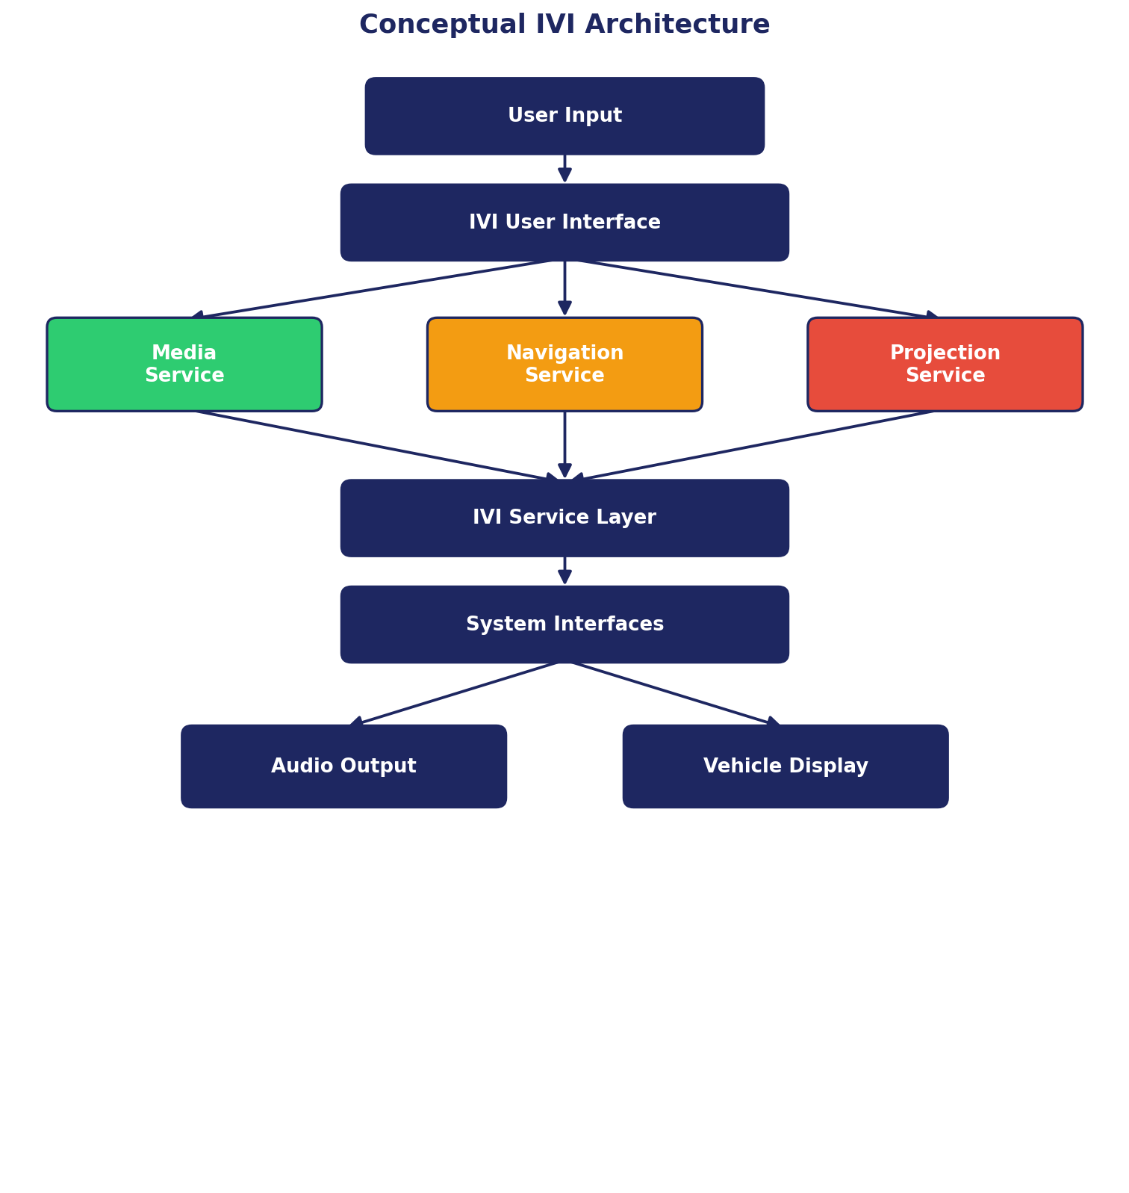
Figure 1. Conceptual IVI architecture integrating media, navigation and projection.

7. Architecture Components

7.1 User Interface
The user interface is the primary interaction point between the driver/passenger and the IVI system. Users can select media, enter navigation destinations and interact with available infotainment functions.

7.2 Media Service
The Media Service manages media-related operations. It receives user commands from the IVI interface and processes requests such as:
- Play
- Pause
- Stop
- Next track
- Previous track
- Volume adjustment
The resulting audio information is passed toward the appropriate audio output interface.

7.3 Navigation Service
The Navigation Service processes navigation-related requests. A typical navigation flow is: destination input → Navigation Service → location information → route calculation → guidance information → vehicle display / projection.

7.4 Projection Service
The Projection Service receives relevant information from services such as navigation and media and prepares it for presentation through the appropriate display. For example, navigation guidance can be projected while media information can continue to be displayed through the infotainment interface.

7.5 Service Layer
The service layer coordinates communication between different IVI functions. It provides an organized interface between applications and lower-level system components.

7.6 System Interfaces
System interfaces provide communication between the IVI software components and hardware/output components. Examples include interfaces associated with:
- Display
- Audio
- Input controls
- Vehicle systems

8. Overall Data Flow
The overall data flow can be represented as shown below.
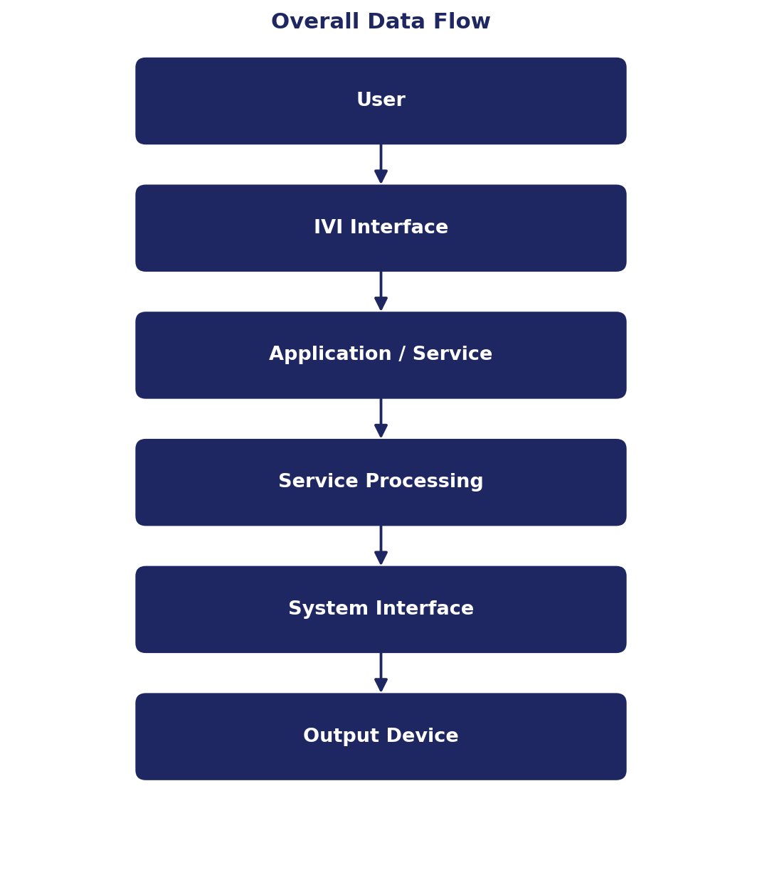
Figure 2. Overall IVI data flow from user input to output device.

9. Media System Flow
The media subsystem begins when a user selects an audio source or media item. The command is received by the IVI interface and forwarded to the Media Service, which processes the request and sends the required audio information toward the audio output system.
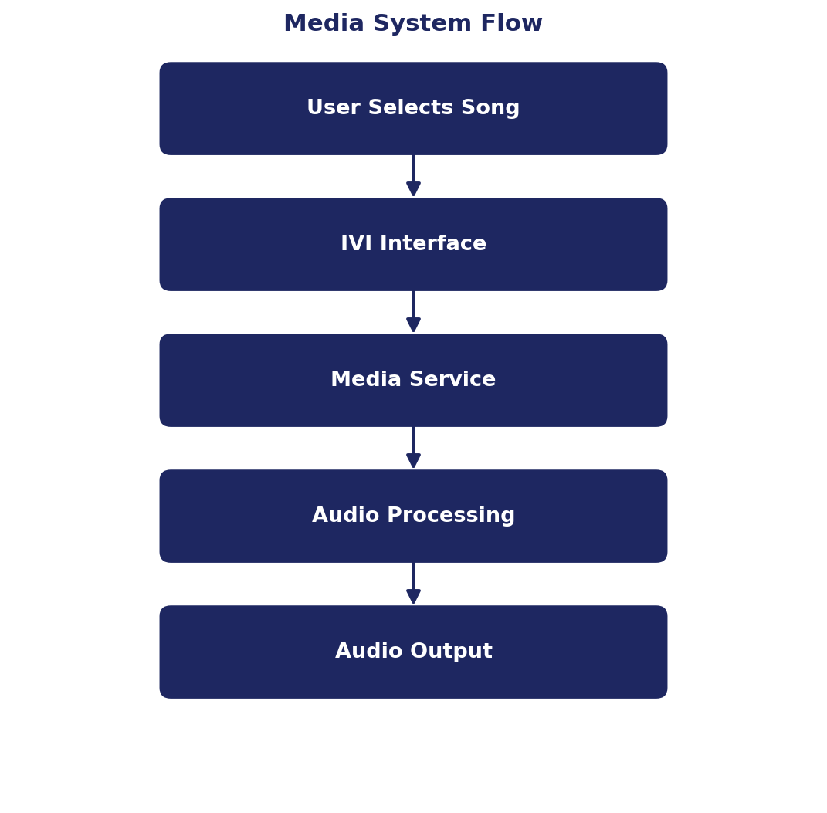
Figure 3. Media system flow.

10. Navigation System Flow
The navigation subsystem receives a destination from the user. The Navigation Service processes the destination together with available location information and generates route guidance.
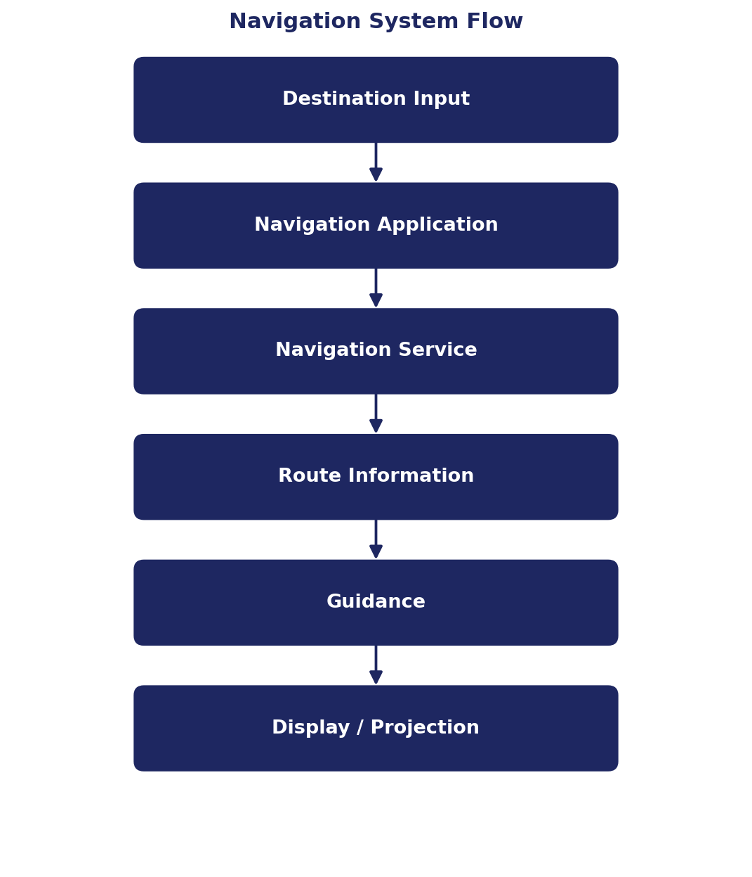
Figure 4. Navigation system flow.

11. Projection System Flow
The projection subsystem receives information that needs to be presented to the driver. For example, navigation guidance can be transferred from the Navigation Service to the Projection Service and then displayed through the appropriate output.
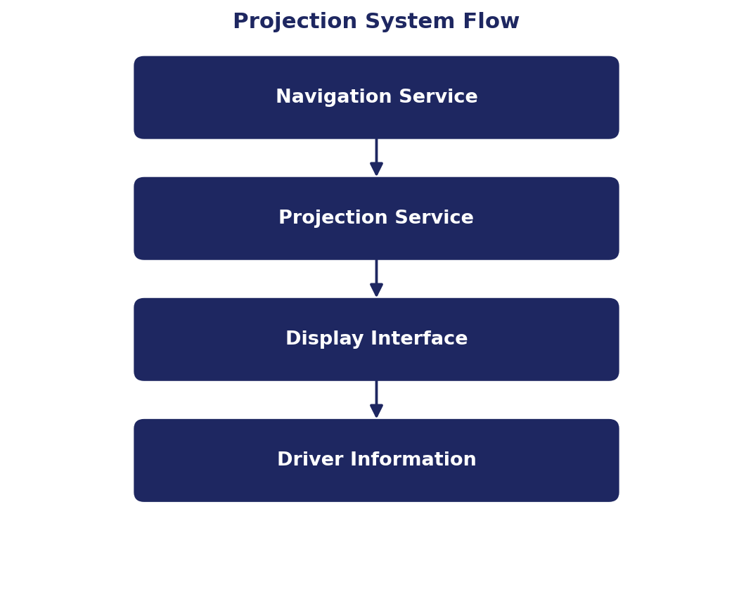
Figure 5. Projection system flow.

12. Component Interfaces
The major interfaces in the proposed architecture are:
Interface | Purpose
User Interface | Receives user commands
Media Interface | Transfers media-related commands/data
Navigation Interface | Transfers navigation requests and guidance
Projection Interface | Transfers information for projection
Audio Interface | Transfers audio toward the output system
Display Interface | Transfers visual information to the display
Service Interface | Enables communication between IVI services

13. Integrated Operation
The main advantage of an integrated IVI architecture is that different services can operate together. For example, a driver may listen to music while navigation is active, as shown below.
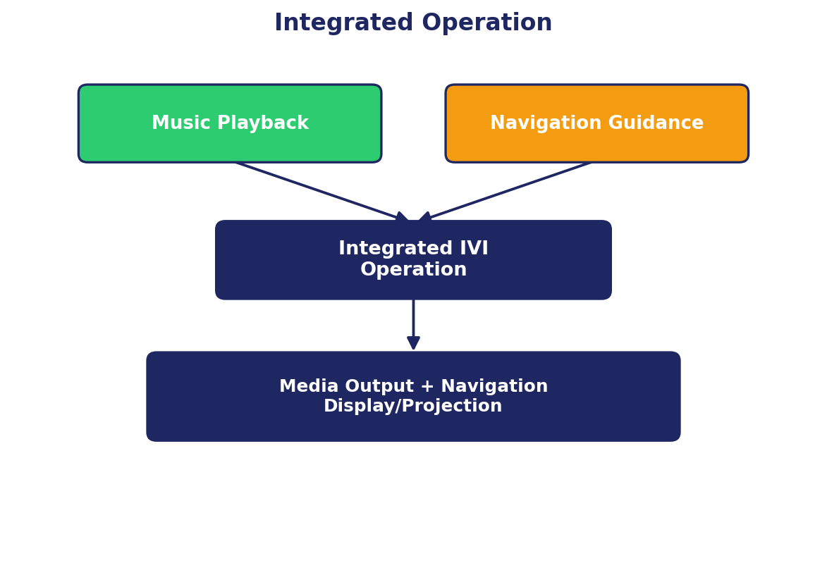
Figure 6. Integrated media and navigation operation.
This allows different infotainment functions to operate within a common system architecture.

14. Example Scenario
Consider a driver travelling to a selected destination while listening to music. First, the driver enters the destination through the IVI interface. The Navigation Service processes the request and generates route guidance.
At the same time, the Media Service continues playing the selected audio. Navigation information can then be presented through the vehicle display or projection system while the audio continues through the vehicle's audio output.
This demonstrates how multiple IVI functions can operate together.

15. Advantages
- Integration of multiple infotainment functions.
- Organized separation of system services.
- Clear data flow between components.
- Integration of media and navigation.
- Support for information projection.
- Centralized user interaction.
- Easier expansion of additional infotainment functions.

16. Limitations
- It does not represent a complete production automotive IVI implementation.
- Detailed hardware specifications are not included.
- Real-time performance has not been experimentally evaluated.
- Specific automotive operating-system implementation details are outside the scope of this conceptual design.
- Actual communication interfaces may vary depending on the vehicle platform.

17. Future Scope
- Android Automotive OS
- Voice assistant functionality
- Smartphone connectivity
- Bluetooth
- Advanced navigation
- Vehicle information services
- Driver assistance information
- Multi-screen display systems
- Personalized user profiles
- Advanced projection systems

18. Expected Result
The expected result is a conceptual architecture showing how media, navigation and projection features can be integrated into a common IVI system.
The architecture identifies the major components, their interfaces and the flow of information between user input, IVI services and vehicle output systems.

19. Conclusion
This project presented a conceptual architecture for an In-Vehicle Infotainment system integrating media, navigation and projection features.
The proposed architecture separates major infotainment functions into dedicated services while providing communication between them through defined interfaces.
Media services manage audio-related operations, navigation services process route and guidance information, and projection services present relevant information to the driver.
The architecture provides a structured foundation for understanding how different infotainment functions can operate together within a modern automotive IVI system.

20. References
1. Module 6 — IVI In-Vehicle Infotainment Systems Project Assignment.
2. In-Vehicle Infotainment system architecture concepts.
3. Automotive media, navigation and display system concepts.

